|  |  |
| --- | --- |
| NAME | J K KUNAL |
| UID | 23BCS11041 |
| CLASS | 622-A |

* JAVASCRIPT PRACTISE 1
* HTML CODE

<!DOCTYPE html>

<html lang="en">

<head>

  <meta charset="UTF-8">

  <meta name="viewport" content="width=device-width, initial-scale=1.0">

  <title>Live Character Counter</title>

  <link rel="stylesheet" href="stylejs1.1.css">

</head>

<body>

  <h2>Live Character Counter</h2>

  <textarea id="textInput" placeholder="Type something..."></textarea>

  <div class="counter">Characters: <span id="charCount">0</span></div>

  <script src="scrpit1.1.js"></script>

</body>

</html>

* CSS CODE

body {

    font-family: Arial, sans-serif;

    margin: 40px;

  }

  textarea {

    width: 100%;

    height: 120px;

    padding: 8px;

    font-size: 14px;

  }

  .counter {

    margin-top: 6px;

    font-size: 14px;

    color: #333;

  }

* JAVASCRIPT CODE

const textarea = document.getElementById("textInput");

const counter = document.getElementById("charCount");

textarea.addEventListener("input", () => {

  counter.textContent = textarea.value.length;

});

* OUTPUT

DEPLOY LINK :- <https://java56--23.bytexl.live/>

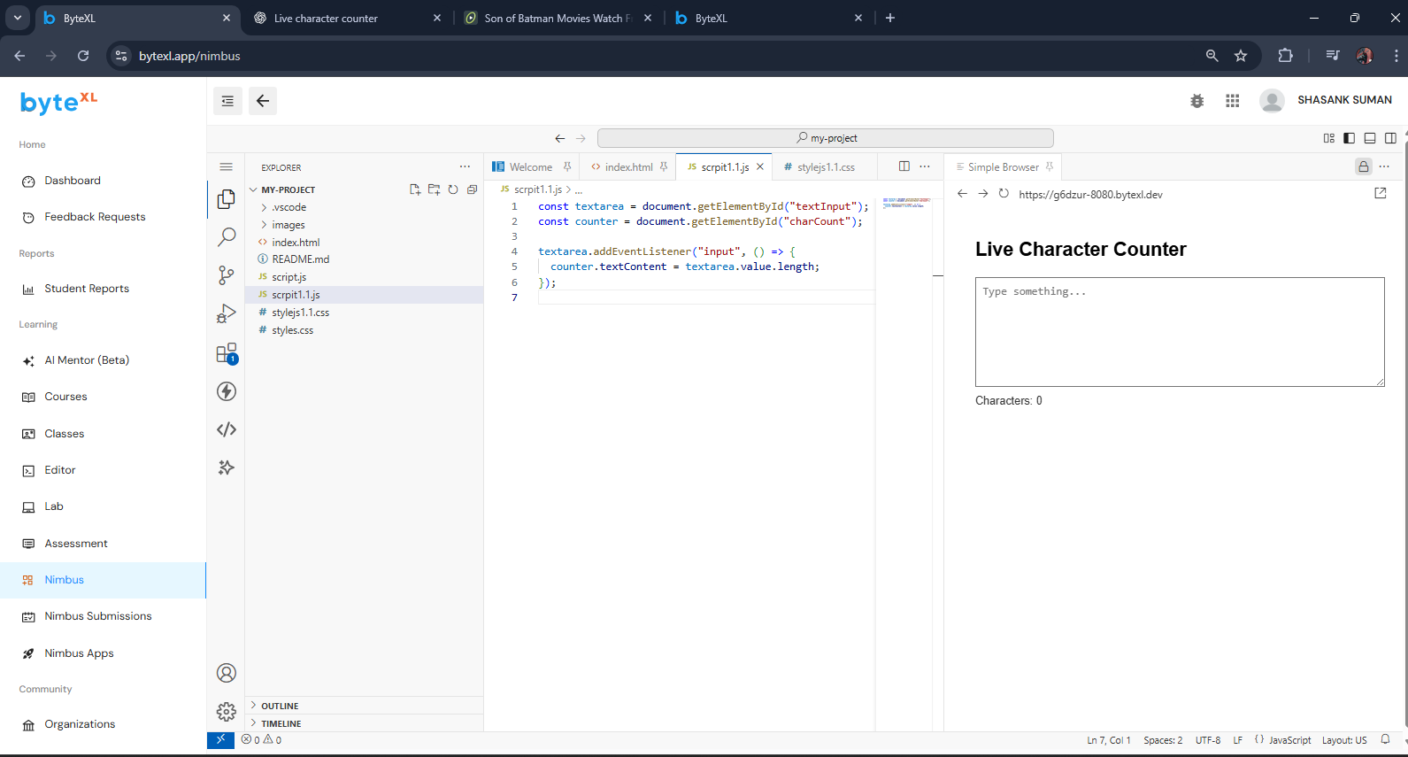

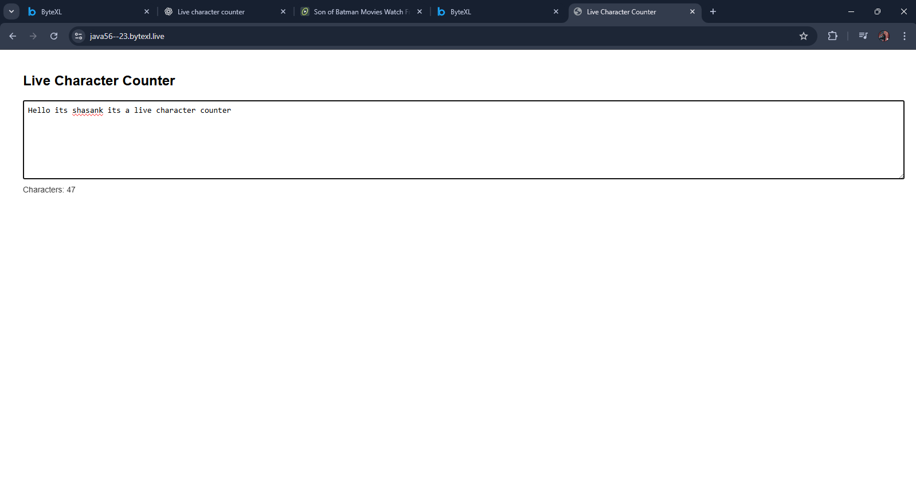

* JAVASCRIPT PRACTISE 2
* HTML CODE

<!DOCTYPE html>

<html lang="en">

<head>

  <meta charset="UTF-8">

  <meta name="viewport" content="width=device-width, initial-scale=1.0">

  <title>Dynamic Product Filter</title>

  <link rel="stylesheet" href="styles1.2.css">

</head>

<body>

  <h2>Dynamic Product Filter</h2>

  <label for="categoryFilter">Filter by Category:</label>

  <select id="categoryFilter">

    <option value="all">All</option>

    <option value="shoes">Shoes</option>

    <option value="shirts">Shirts</option>

    <option value="gadgets">Gadgets</option>

  </select>

  <div id="productList" class="product-list">

    <div class="product" data-category="shoes">Running Shoes</div>

    <div class="product" data-category="shirts">Casual Shirt</div>

    <div class="product" data-category="gadgets">Smartphone</div>

    <div class="product" data-category="shoes">Formal Shoes</div>

    <div class="product" data-category="shirts">T-Shirt</div>

    <div class="product" data-category="gadgets">Headphones</div>

  </div>

  <script src="script1.2.js"></script>

</body>

</html>

* CSS CODE

body {

  font-family: Arial, sans-serif;

  margin: 40px;

}

h2 {

  margin-bottom: 10px;

}

label {

  margin-right: 10px;

}

select {

  padding: 5px;

  margin-bottom: 20px;

}

.product-list {

  display: flex;

  flex-wrap: wrap;

  gap: 10px;

}

.product {

  padding: 10px 15px;

  border: 1px solid #ccc;

  border-radius: 5px;

  background: #f8f8f8;

}

* JAVASCRIPT CODE

const filterDropdown = document.getElementById("categoryFilter");

const products = document.querySelectorAll(".product");

filterDropdown.addEventListener("change", () => {

  const selectedCategory = filterDropdown.value;

  products.forEach(product => {

    const productCategory = product.getAttribute("data-category");

    if (selectedCategory === "all" || productCategory === selectedCategory) {

      product.style.display = "block";

    } else {

      product.style.display = "none";

    }

  });

});

* OUTPUT

DEPOLY LINK :- <https://javas12-h.bytexl.live/>

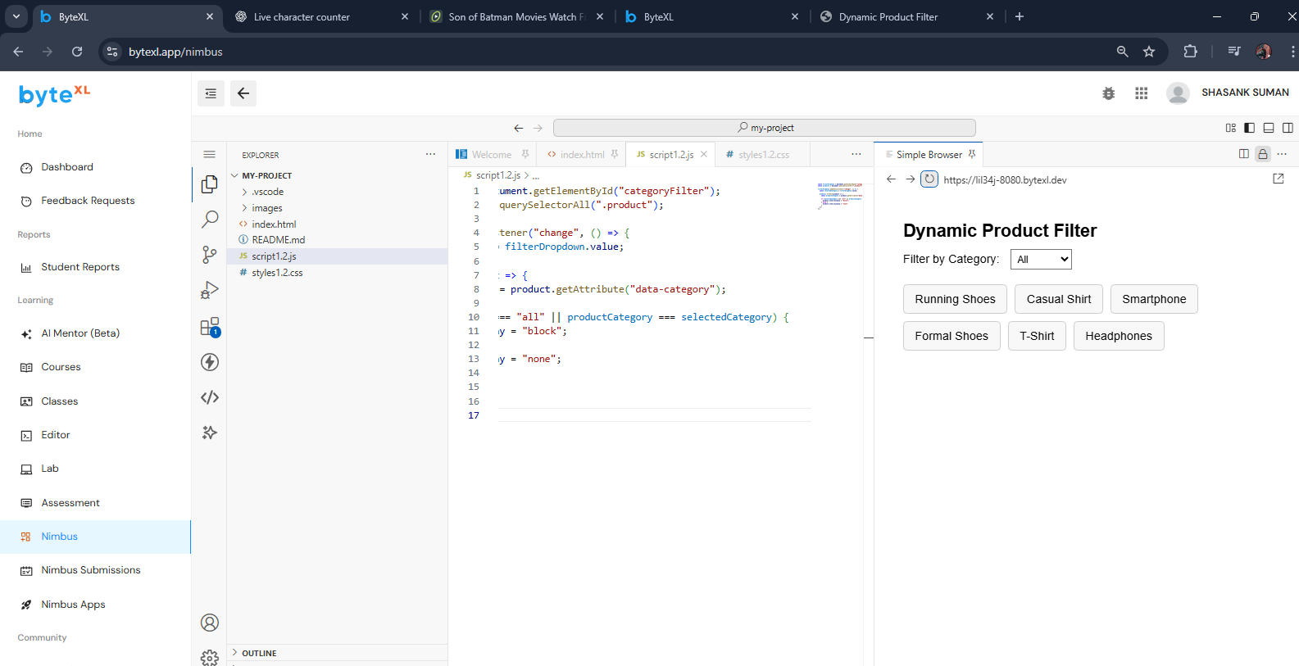

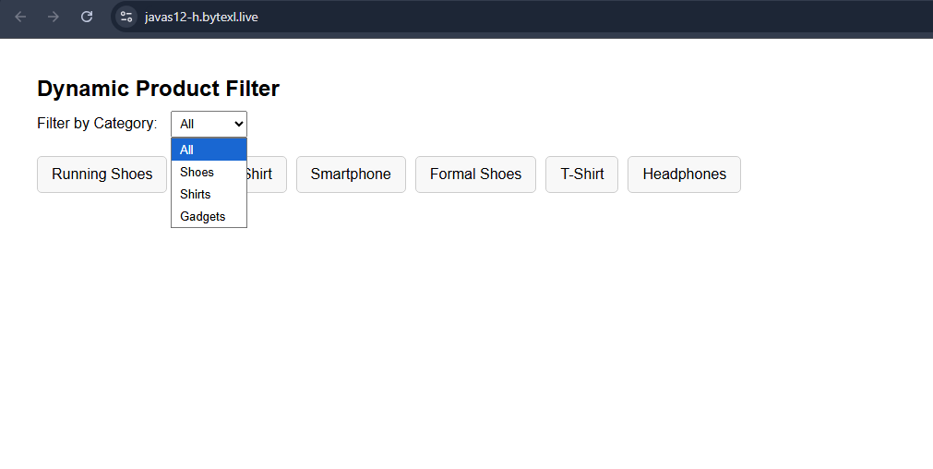

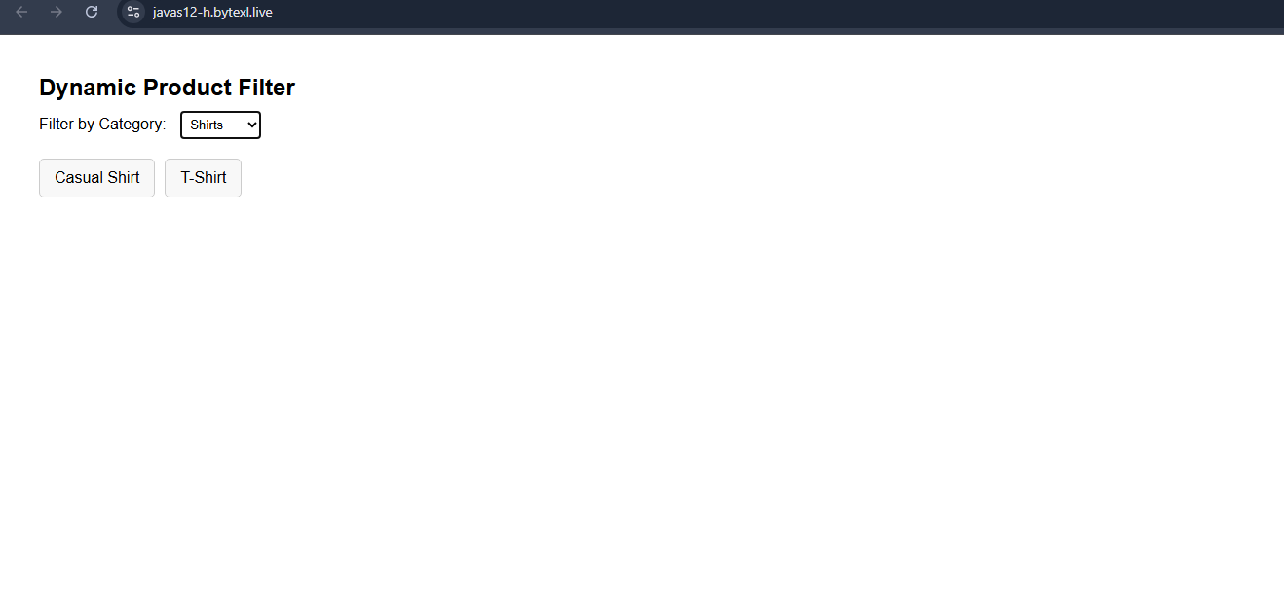

* JAVASCRIPT PRACTISE 3
* HTML CODE

<!DOCTYPE html>

<html lang="en">

<head>

  <meta charset="UTF-8" />

  <meta name="viewport" content="width=device-width, initial-scale=1.0"/>

  <title>Interactive SVG Drawing Tool</title>

  <link rel="stylesheet" href="styles1.3.css"/>

</head>

<body>

  <header>

    <h1>Interactive SVG Drawing Tool (SVG + Mouse Events)</h1>

    <div class="toolbar">

      <label>

        Shape:

        <select id="shapeSelect">

          <option value="line">Line</option>

          <option value="rect">Rectangle</option>

          <option value="ellipse">Ellipse</option>

        </select>

      </label>

      <label>

        Stroke:

        <input type="color" id="strokeColor" value="#2d6cdf" />

      </label>

      <label>

        Width:

        <input type="number" id="strokeWidth" min="1" max="20" value="2" />

      </label>

      <label class="fill-toggle">

        Fill:

        <input type="color" id="fillColor" value="#000000" />

        <input type="checkbox" id="fillEnable" />

        <span>enable</span>

      </label>

      <button id="clearBtn" type="button">Clear Canvas</button>

    </div>

  </header>

  <main>

    <div class="canvas-wrap">

      <!-- SVG drawing area -->

      <svg id="drawingArea" width="900" height="520" viewBox="0 0 900 520" tabindex="0" aria-label="SVG drawing canvas">

        <!-- Optional background grid -->

        <defs>

          <pattern id="grid" width="20" height="20" patternUnits="userSpaceOnUse">

          <path d="M 20 0 L 0 0 0 20" fill="none" stroke="rgba(0,0,0,.08)" stroke-width="1"/>

          </pattern>

        </defs>

        <rect x="0" y="0" width="100%" height="100%" fill="url(#grid)"/>

        <!-- All shapes will be appended into this group -->

        <g id="shapesLayer"></g>

      </svg>

    </div>

    <p class="hint">

      Tip: Choose a shape, then click and drag on the canvas to draw. Release to finish. Repeat to draw multiple shapes.

    </p>

  </main>

  <script src="script1.3.js"></script>

</body>

</html>

* CSS CODE

* { box-sizing: border-box; }

body {

  margin: 0;

  font-family: system-ui, -apple-system, Segoe UI, Roboto, Arial, sans-serif;

  color: #1f2937;

  background: #f7fafc;

}

header {

  background: #ffffff;

  border-bottom: 1px solid #e5e7eb;

  padding: 16px 20px;

}

h1 {

  margin: 0 0 10px 0;

  font-size: 18px;

  font-weight: 600;

}

.toolbar {

  display: flex;

  flex-wrap: wrap;

  gap: 12px;

  align-items: center;

}

.toolbar label {

  display: inline-flex;

  align-items: center;

  gap: 8px;

  font-size: 14px;

}

.fill-toggle {

  display: inline-flex;

  align-items: center;

  gap: 6px;

}

button {

  appearance: none;

  border: 1px solid #cbd5e1;

  background: #fff;

  padding: 8px 12px;

  border-radius: 8px;

  cursor: pointer;

  font-size: 14px;

}

button:hover { background: #f1f5f9; }

main {

  padding: 18px 20px 28px;

}

.canvas-wrap {

  background: #ffffff;

  border: 1px solid #e5e7eb;

  border-radius: 12px;

  padding: 10px;

  overflow: auto;

  box-shadow: 0 2px 10px rgba(0,0,0,.04);

}

svg#drawingArea {

  display: block;

  border-radius: 8px;

  outline: none;

  background: #fff;

}

svg#drawingArea.drawing { cursor: crosshair; }

.hint {

  color: #6b7280;

  font-size: 13px;

  margin-top: 10px;

}

* JAVASCRIPT CODE

const svg = document.getElementById("drawingArea");

const layer = document.getElementById("shapesLayer");

const shapeSelect  = document.getElementById("shapeSelect");

const strokeColor  = document.getElementById("strokeColor");

const strokeWidth  = document.getElementById("strokeWidth");

const fillColor    = document.getElementById("fillColor");

const fillEnable   = document.getElementById("fillEnable");

const clearBtn     = document.getElementById("clearBtn");

let isDrawing = false;

let start = { x: 0, y: 0 };

let currentEl = null;

const SVG_NS = "http://www.w3.org/2000/svg";

function getSvgPoint(evt) {

  const rect = svg.getBoundingClientRect();

  return {

    x: evt.clientX - rect.left,

    y: evt.clientY - rect.top

  };

}

function styleElement(el) {

  el.setAttribute("stroke", strokeColor.value);

  el.setAttribute("stroke-width", strokeWidth.value);

  el.setAttribute("vector-effect", "non-scaling-stroke");

  if (fillEnable.checked) {

    el.setAttribute("fill", fillColor.value);

    el.setAttribute("fill-opacity", 0.2);

  } else {

    el.setAttribute("fill", "none");

  }

}

svg.addEventListener("mousedown", (evt) => {

  isDrawing = true;

  svg.classList.add("drawing");

  start = getSvgPoint(evt);

  const type = shapeSelect.value;

  if (type === "line") {

    currentEl = document.createElementNS(SVG_NS, "line");

    currentEl.setAttribute("x1", start.x);

    currentEl.setAttribute("y1", start.y);

    currentEl.setAttribute("x2", start.x);

    currentEl.setAttribute("y2", start.y);

  } else if (type === "rect") {

    currentEl = document.createElementNS(SVG_NS, "rect");

    currentEl.setAttribute("x", start.x);

    currentEl.setAttribute("y", start.y);

    currentEl.setAttribute("width", 0);

    currentEl.setAttribute("height", 0);

  } else if (type === "ellipse") {

    currentEl = document.createElementNS(SVG_NS, "ellipse");

    currentEl.setAttribute("cx", start.x);

    currentEl.setAttribute("cy", start.y);

    currentEl.setAttribute("rx", 0);

    currentEl.setAttribute("ry", 0);

  }

  styleElement(currentEl);

  layer.appendChild(currentEl);

});

svg.addEventListener("mousemove", (evt) => {

  if (!isDrawing || !currentEl) return;

  const pos = getSvgPoint(evt);

  const type = shapeSelect.value;

  if (type === "line") {

    currentEl.setAttribute("x2", pos.x);

    currentEl.setAttribute("y2", pos.y);

  } else if (type === "rect") {

    const x = Math.min(pos.x, start.x);

    const y = Math.min(pos.y, start.y);

    const w = Math.abs(pos.x - start.x);

    const h = Math.abs(pos.y - start.y);

    currentEl.setAttribute("x", x);

    currentEl.setAttribute("y", y);

    currentEl.setAttribute("width", w);

    currentEl.setAttribute("height", h);

  } else if (type === "ellipse") {

    const rx = Math.abs(pos.x - start.x) / 2;

    const ry = Math.abs(pos.y - start.y) / 2;

    const cx = (pos.x + start.x) / 2;

    const cy = (pos.y + start.y) / 2;

    currentEl.setAttribute("cx", cx);

    currentEl.setAttribute("cy", cy);

    currentEl.setAttribute("rx", rx);

    currentEl.setAttribute("ry", ry);

  }

});

function endDrawing() {

  if (!isDrawing) return;

  isDrawing = false;

  svg.classList.remove("drawing");

  if (currentEl) {

    const tag = currentEl.tagName;

    let tooSmall = false;

    if (tag === "line") {

      const x1 = +currentEl.getAttribute("x1");

      const y1 = +currentEl.getAttribute("y1");

      const x2 = +currentEl.getAttribute("x2");

      const y2 = +currentEl.getAttribute("y2");

      const len = Math.hypot(x2 - x1, y2 - y1);

      tooSmall = len < 2;

    } else if (tag === "rect") {

      const w = +currentEl.getAttribute("width");

      const h = +currentEl.getAttribute("height");

      tooSmall = w < 2 || h < 2;

    } else if (tag === "ellipse") {

      const rx = +currentEl.getAttribute("rx");

      const ry = +currentEl.getAttribute("ry");

      tooSmall = rx < 1 || ry < 1;

    }

    if (tooSmall) currentEl.remove();

  }

  currentEl = null;

}

svg.addEventListener("mouseup", endDrawing);

svg.addEventListener("mouseleave", endDrawing);

clearBtn.addEventListener("click", () => {

  while (layer.firstChild) layer.removeChild(layer.firstChild);

});

svg.addEventListener("touchstart", (e) => {

  e.preventDefault();

  const t = e.touches[0];

  svg.dispatchEvent(new MouseEvent("mousedown", { clientX: t.clientX, clientY: t.clientY }));

}, { passive: false });

svg.addEventListener("touchmove", (e) => {

  e.preventDefault();

  const t = e.touches[0];

  svg.dispatchEvent(new MouseEvent("mousemove", { clientX: t.clientX, clientY: t.clientY }));

}, { passive: false });

svg.addEventListener("touchend", (e) => {

  e.preventDefault();

  svg.dispatchEvent(new MouseEvent("mouseup"));

}, { passive: false });

* OUTPUT

DEPLOY LINK:- <https://java13-js.bytexl.live/>

